Kotlin Cookbook

by
Ken Kousen

Basic Kotlin

Nullable

Define the type variable with a question mark. With Nullable types also you can combine safe call operator ?. and Elvis operator ?:

Safe call operator ?. Returns a null if the value is null
val middleNameLength = p.middle?.length // resulting type is Int?

Elvis operator ?: returns default value if variable is null
val middleNameLength = p.middle?.length ?: 0 // resulting type is Int

The righthand side of an Elvis operator can be an expression, so you can use return or throw when checking function arguments

Safe cast operator as?
If cast is not going to work ClassCastEx will not be thrown
val p1 = p as? AS Person // p1 is of type Person?

@Nonnull from Java

Enforce JSR-305 nullability annotations in your Kotlin code, using the compile-time parameter -Xjsr305=strict.
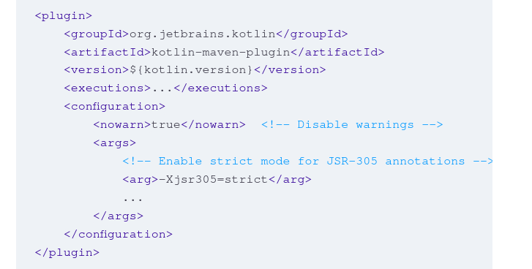

Default arguments into Java

IF you are calling Kotlin from Java code and Kotlin method has default arguments annotate it with
@JvmOverloads
Same is for constructors

Create Pair Instance

The Pair class properties first and second correspond to the generic values of A and B. Although you can create a Pair class by using the two-argument constructor, it is more common to use the to function. The to function is defined as follows:
public infix fun <A, B> A.to(that: B): Pair<A, B> = Pair(this, that)

Rather than instantiate the Pair class directly, use the infix to function

val p1 = Pair("a", 1)
val p2 = "a" to 1

because Pair is a data class, the individual elements can be accessed by using destructuring

Object Oriented

const and val

val is a Kotlin keyword, but const is a modifier, like private, inline, and so on. That’s why const must be used along with the keyword val rather than replacing it. It add compile-time constants
- must be top-level properties or members of an object declaration or a companion object
- They must be of type String or a primitive type wrapper class (Byte, Short, Int, Long, Float, Double, Char, or Boolean)
- hey cannot have a custom getter function
- They must be assigned outside any function, including main, because their values must be known at compile time
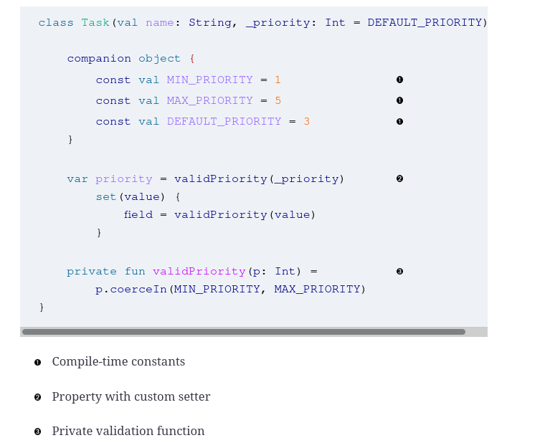

The parameter _priority is not a property (it is not var or val), but rather just an argument to the constructor. It is used to initialize the actual priority property, and the custom setter is evaluated to coerce it into the desired range every time it changes

var p = getVal()
set(value) {
field = getVal()
}
private fun getVal(): Int = 45
Be careful custom set function is called when object.t is called, so you need also here set value var p = getVal()

Data Classes

indicate that is for data hold only. It will generate equals, hash, and toString, copy
The copy method is an instance method that creates a new object that starts with the property values from the original and modifies only the supplied values,

val p2 = p1.copy(price = 12.0) // it is shallow copy

After spending almost a full year of writing Kotlin daily I've found that attempting to override data classes like this is a bad practice.

Lazy loading property
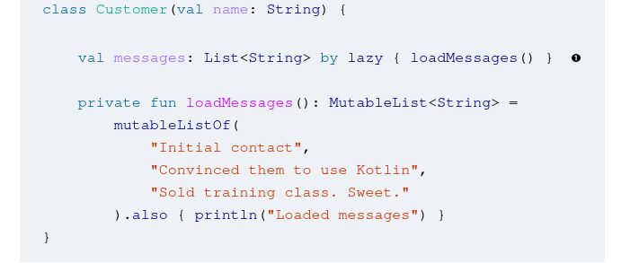
same as

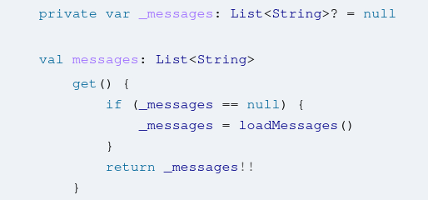

Delay initialization

If you don’t have enough information to init a property in a constructor, but you don’t want to have to make the property nullable as a result use the lateinit modifier on your property
Use tis techniques sparingly, only when necessary also consider alternatives like the lazy evaluation.

For example, the Spring framework uses the annotation @Autowired to assign values to dependencies from the so-called application context. Again, since the value is set after the instances have already been created, mark it as lateinit

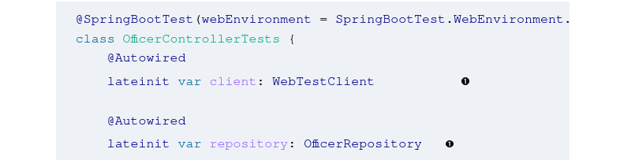

The lateinit modifier can be used only on var properties declared inside the body of a class, and only when the property does not have a custom getter or setter. Since Kotlin 1.2, you can also use lateinit on top-level properties and even local variables. The type must be non-null, and it cannot be a primitive type.
By adding lateinit, you are promising to initialize the variable before it is first used. Otherwise, it throws an exception UninitializedPropertyAccessException

Also, lazy can be used only for val properties, whereas lateinit can be applied only to var properties. Finally, lateinit properties can be initialized from anywhere the property is visible

Equals

override fun equals(other: Any?): Boolean {
if (this === other) return true
val otherVersion = (other as? KotlinVersion) ?: return false
return this.version == otherVersion.version
}

Singleton
Use the object keyword instead of class
The blog post “Kotlin Singletons with Argument” by Christophe Beyls discusses ways to handle arguments based on the implementation of the lazy delegate in the Kotlin library.

Functional Programing

Fold

Use the fold function to reduce a sequence or collection to a single value.

The fold function is a reduction operation that can be applied to arrays or iterables. The syntax of the function is given by the following:
inline fun <R> Iterable<T>.fold(
initial: R,
operation: (acc: R, T) -> R
): R
The idea is that fold takes two parameters: an initial value for the accumulator, and a function of two arguments that returns a new value for the accumulator.

Example:
fun sum(vararg nums: Int) =
nums.fold(0) { acc, n -> acc + n }

Reduce

To reduce a sequence or collection to a single value, but without need to set an initial value for the accumulator. Same purpose as fold but is does not have an argument that provides an initial value for the accumulator.. The accumulator is initialized with the first value form the collection

inline fun <S, T : S> Iterable<T>.reduce(
operation: (acc: S, T) -> S
): S
Example
fun sumReduce(vararg nums: Int) =
nums.reduce { acc, i -> acc + i }
Tail Recursion
You have a recursive process and want to minimize the memory required to execute it so express you recursive function (process) by adding keyword tailrec to function

To summarize, the requirements for a function to be eligible for the tailrec modifier are as follows:
- The function must call itself as the last operation it performs.
- You cannot use tailrec inside try/catch/finally blocks.
- Tail recursion is supported only on the JVM backend.

Collections

Arrays
arrayOf → to create them

Kotlin has specialized classes to represent arrays of primitive types to avoid the cost of autoboxing and unboxing. The functions booleanArrayOf

(index, value) in array.withIndex() → get index and value

Create collection

listOf, setOf, mapOf form mutable mutableListOf …

Create a Map from a Collection

Use the associateWith function by supplying a lambda to be executed for each key.

The associate function is an inline extension function on Iterable<T> that takes a lambda that transforms T into a Pair<K,V>. In this example, the to function is an infix function that produces a Pair from the left- and right-side arguments.

Return a default when a collection is empty

use ifEmpty()

Restricting a Value to a Given Range

use coerceIn

Use the chunked function if you want to divide the collection into equal parts, or the windowed function if you want a block that slides along the collection by a given interval.
Takes three arguments (optional): size, step, partialWindows

Destructuring is the process of extracting values from an object by assigning them to a collection of variables

val (a, b, c, d, e) = list

Sorting

You want to sort a class by one property, and then equal values by a second property, and so on.
Use the sortedWith and compareBy functions

val sorted = golfers.sortedWith(
compareBy({ it.score }, { it.last }, { it.first })
)

sorted.forEach { println(it) }

What’s interesting about compareBy is that you can provide a list of selectors, each of which extracts a Comparable property (note that the property’s class has to implement the Comparable interface), and the function will create a Comparator that sorts by them in turn. Require mutable collections.

Create own iterator

You have a class that wraps a collection and you would like to iterate over it easily.
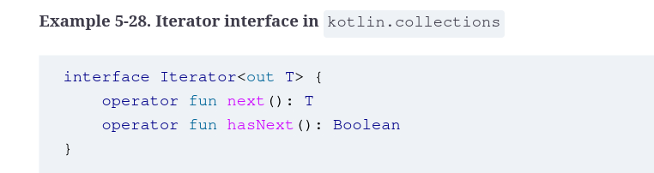
Todo

Collections in Kotlin include an extension function called filter that takes a predicate, which can be used to extract elements satisfying any boolean condition,

Range when you have custom objects

In Kotlin, a range is created when you use the double dot operator, as in 1..5, which instantiates an IntRange. A range is a closed interval, defined by two endpoints that are both included in the range

todo

Sequences

same as Java streams

With collections, processing is eager: when you invoke map or filter on a collection, every element in the collection is processed. Sequences, however, are lazy: when you use a sequence to process data, each element completes the entire pipeline before the next element is processed. This helps when you have a lot of data or if a short-circuiting operation, like first, lets you exit the sequence when a desired value is found.

he API for Sequence contains the same functions as that for Collection, but the operations fall into two categories: intermediate and terminal. Intermediate operations, like map and filter, return a new sequence. Terminal operations, like first or toList, return anything else. The key is that without a terminal operation, a sequence will not process any data.
To generate a sequence of values → Use sequenceOf if you already have the elements, use asSequence if you already have an Iterable, or use a sequence generator otherwise.

You need a portion of an infinite sequence → Use a sequence generator that returns a null, or use one of the sequence functions such as takeWhile.

You want to produce values in a sequence, but at specified intervals. Use the sequence function along with the yield suspend function.

Scope Functions

The Kotlin standard library contains several functions whose purpose is to execute a block of code in the context of an object (let, run, apply, also..).

Initialize Objects After Construction with apply

The apply function is an extension function that sends this as an argument and returns it as well.

inline fun <T> T.apply(block: T.() -> Unit): T

It is most commonly used to do additional configuration of objects that have already been instantiated.

Use also for side effects

You want to print a message or other side effect without interrupting the flow of your code.
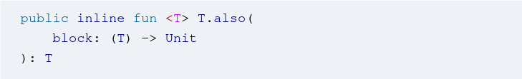

As the code shows, also is added to any generic type T, which it returns after executing the block argument. It is most commonly used to chain a function call onto an object

Inside the block, the object is referenced as it.

val book = createBook()
.also { println(it) }
.also { Logger.getAnonymousLogger().info(it.toString()) }

Because also returns the context object, it’s easy to chain additional calls together, as shown here, where the book was first printed to the console and then logged somewhere.

While it’s useful to see that you can chain multiple also calls together, the function is more typically added as part of a series of business logic calls
Let function and Elvis

You want to execute a block of code only on a non-null reference, but return a default otherwise.

The key fact to remember about let is that it returns the result of the block, rather than the context object. It therefore acts like a transformation of the context object, sort of like a map for objects. Say you want to take a string and capitalize it, but require special handling for empty or blank strings

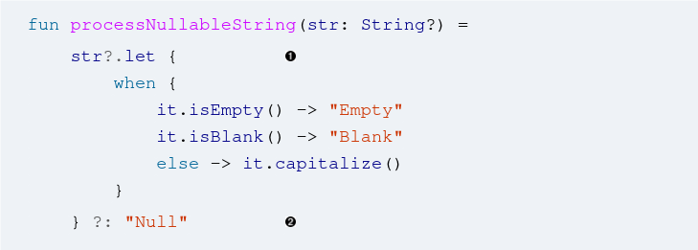

No need to assign the result to a temporary variable.

Chain a let call to the calculation and process the result in the supplied lambda or function reference.

numbers.map { it.length }.filter { it > 3 }.let {
println(it)
// and more function calls if needed
}
The idea is that rather than assign the result to a temporary variable, the chained let call uses the result as its context variable, so it can be printed (or more) in the provided block. If all that is required is to print the result, this can even be reduced further,

Kotlin Delegates

Class delegates let you replace inheritance with composition, and property delegates replace the getters and setters for a property with those from another class.

Implement composition by delegation

You want to create a class that contains instances of other classes and delegate behavior to them.
Create interfaces that contain the delegation methods, implement them in classes, and build the wrapper class out of them using the keyword by.

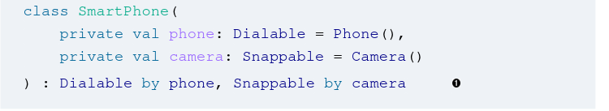

Now instantiating a SmartPhone allows you to invoke all the methods in Phone or Camera

Lazy Delegate

Kotlin uses the by keyword on properties to imply that its getter and setter are implemented by a different object, called a delegate. Several delegate functions are in the standard library. One of the most popular is called lazy

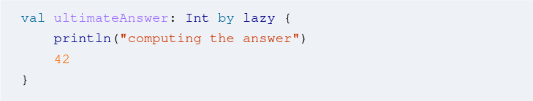

The idea is that the value of ultimateAnswer is not computed until it is first accessed, at which point the lambda expression is evaluated. In the implementation, lazy is a function that takes a lambda and returns an instance of Lazy<Int> that will execute the lambda when the property is first accessed.

Ensure that a value is not null

You want to throw an exception if a value has not been initialized before first access.
Use the notNull function to provide a delegate that throws an exception if the value has not been set.

Look Delegates.kt in the standard library

Using the observable and vetoable delegated

You want to intercept changes to a property and optionally veto them.

Use the observable function to detect changes, and the vetoable function with a lambda to decide whether to implement them.

the observable and vetoable functions in the Delegates object in the standard library are easy to use, but the implementations demonstrate a good pattern for writing your own.

fun <T> observable(
initialValue: T,
onChange: (property: KProperty<*>, oldValue: T, newValue: T) -> Unit
): ReadWriteProperty<Any?, T>

fun <T> vetoable(
initialValue: T,
onChange: (property: KProperty<*>, oldValue: T, newValue: T) -> Boolean
): ReadWriteProperty<Any?, T>
Both factory functions take an initial value of type T and a lambda, and return an instance of a class that implements the ReadWriteProperty interface. Using them is straightforward,

var watched: Int by Delegates.observable(1) { prop, old, new ->
println("${prop.name} changed from $old to $new")
}

var checked: Int by Delegates.vetoable(0) { prop, old, new ->
println("Trying to change ${prop.name} from $old to $new")
new >= 0
}
Using either function is pretty straightforward, but again the really interesting part is the way they are implemented. As with notNull, both observable and vetoable are factory functions in the singleton Delegates object, as in

inline fun <T> observable(initialValue: T,
crossinline onChange: (property: KProperty<*>,
oldValue: T, newValue: T) -> Unit): ReadWriteProperty<Any?, T> =
object : ObservableProperty<T>(initialValue) {
override fun afterChange(property: KProperty<*>,
oldValue: T, newValue: T) = onChange(property, oldValue, newValue)
}

inline fun <T> vetoable(initialValue: T,
crossinline onChange: (property: KProperty<*>,
oldValue: T, newValue: T) -> Boolean): ReadWriteProperty<Any?, T> =
object : ObservableProperty<T>(initialValue) {
override fun beforeChange(property: KProperty<*>,
oldValue: T, newValue: T): Boolean =
onChange(property, oldValue, newValue)
}

Supplying Maps as Delegates

You want to supply a map of values to initialize an object.
If the values you need to initialize an object are in a map, you can automatically delegate the class properties to that map.

data class Project(val map: MutableMap<String, Any?>) {
val name: String by map
var priority: Int by map
var completed: Boolean by map
}
This works because MutableMap has extension functions setValue and getValue with the proper signatures, as required in order to be a ReadWriteProperty delegate

todo: https://learning.oreilly.com/library/view/kotlin-cookbook/9781492046660/ch08.html#delegated_properties stao I pogledaj sve o delefatima jos jednom

